Introducing our Interim Minister - Jonathan Chaffey

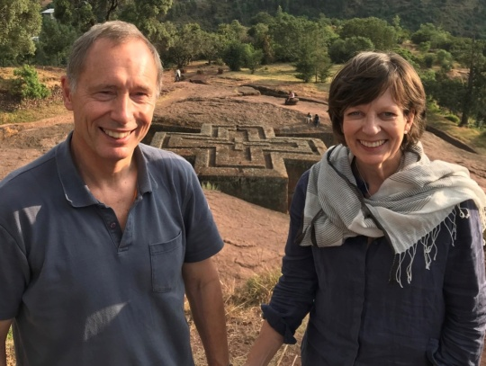

Dear Friends,

Some of you may already know that I have been appointed as an Interim Minister for the Hambleden Valley Group of Churches until Easter Sunday (12th April). I am delighted to work alongside the churchwardens in supporting the parishes during this time, whether through taking services, offering pastoral care or simply encouraging the life of the church in our communities.

My wife, Jane, and I have enjoyed our links with the parishes over several years, having officiated at services in several of the villages while I ministered within the Royal Air Force and during Jane's time as School Chaplain at Wycombe Abbey. We know the warmth of the welcome in the villages and are looking forward to sharing your life through the Epiphany and Lent into Easter.

To introduce ourselves I am attaching a photo of ourselves standing above one of the extraordinary, 12th century rock-hewn churches of Lalibela in Ethiopia. King Lalibela, looking to create a 'New Jerusalem', arranged 11 churches to be constructed. The story goes that the churches were completed in such quick time that the hard work of the builders was surely complemented by the ministry of angels at night. The church in the photo is the Church of St George. It is as we see the Cross of Jesus at the centre of our lives that we can also discover his extraordinary grace at work.

With prayers and best wishes,
Jonathan

Ven Jonathan Chaffey
hambledenvalleyminister@gmail.com

